Q1)

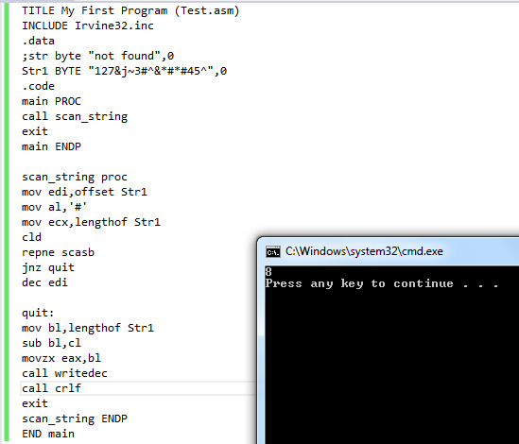

Q2)

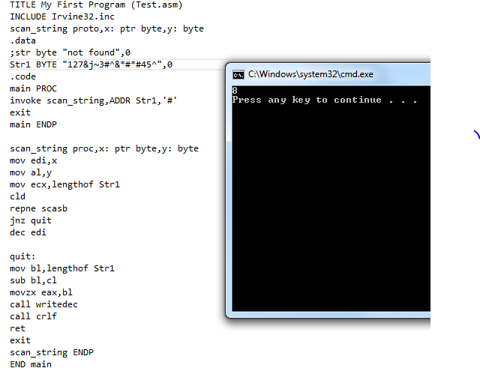

Q3)

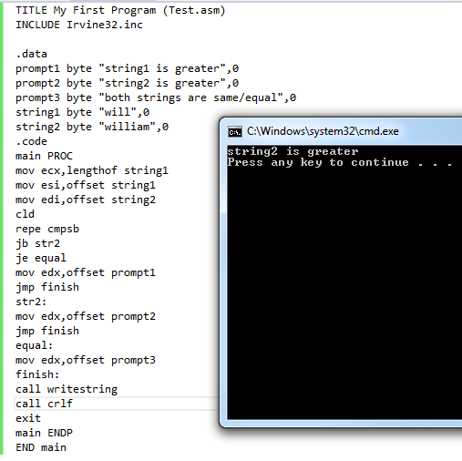

Q4)

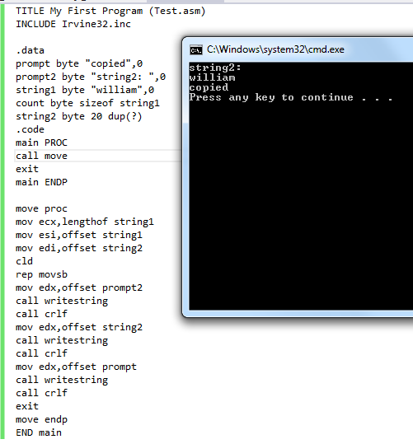

Q5)

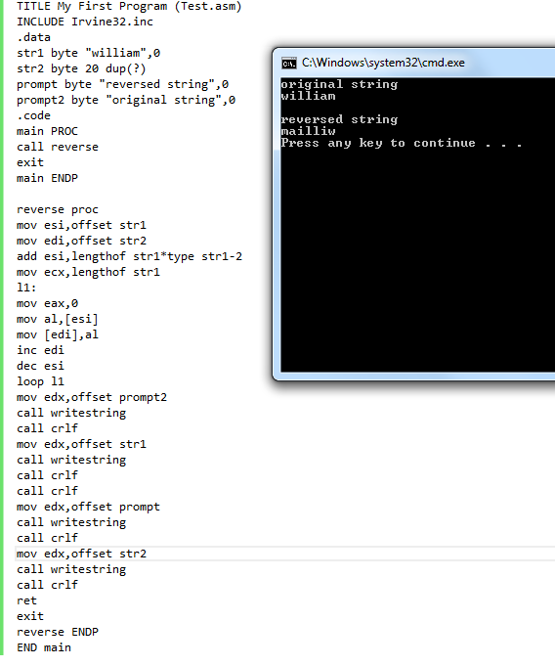

Q6)

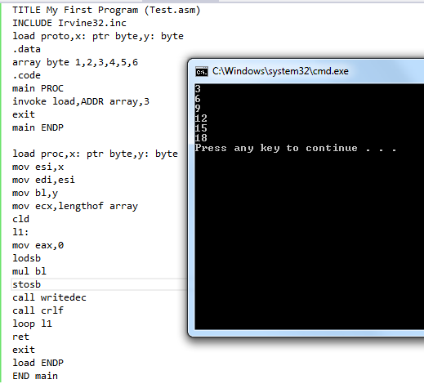

Q7)

INCLUDE Irvine32.inc

.data

target BYTE " AAABDCFBBC" , 0

freqTable DWORD 256 DUP( 0)

.code

main PROC

call Clrscr

call Get_frequencies

call DisplayTable

exit

main ENDP

Get_frequencies PROC,

pString:PTR BYTE,; points to string

pTable:PTR DWORD; points to frequencey table

mov esi,offset target

mov edi,offset freqTable

cld; clear Direction flag (forward)

L1:mov eax,0; clear upper bits of EAX

lodsb; AL = [ESI], inc ESI

cmp al,0; end of string?

je Exit_proc; yes: exit

shl eax,2; multiply by 4

inc DWORD PTR[edi+eax]; add to table entry

jmp L1; repeat loop

Exit_proc:

ret

Get_frequencies ENDP

DisplayTable PROC

.data

colonStr BYTE ": ",0

.code

call Crlf

mov ecx,LENGTHOF freqTable; entries to show

mov esi,OFFSET freqTable

mov ebx,0; index counter

L1: mov eax,[esi]; get frequency count

cmp eax,0; count = 0?

jna L2; if so, skip to next entry

mov eax, ebx; display the index

call WriteChar

mov edx, OFFSET colonStr; display ": "

call WriteString

mov eax,[esi]; show frequency count

call WriteDec

call Crlf

L2:add esi, TYPE freqTable; point to next table entry

inc ebx; increment index

loop L1

call Crlf

ret

DisplayTable ENDP

END main